**CYCLE 1**

1. Print your name to the screen with every letter being a different heading size

<html>

NEW <head>

<title>

PROGRAM

</title>

</head>

<body align="center">

My Name is:

<h1>M</h1><h2>O</h2><h3>N</h3><h4>I</h4><h5>C</h5><h6>A</h6>

</body>

</html>

2. Display the following text:

H2O

12th April 2016

HTML stands for ~~High Text Markup Language~~

He said <**I am fine**>

<html>

<head>

<title>PROGRAM 2</title>

</head>

<body>

H2O<br><br>

12th April 2016<br><br>

HTML stands for <strike>High Text Markup Language</strike><br><br>

He said&ltI am fine&gt<br><br>

</body>

</html>

3. Print a paragraph with 4 - 5 sentences. Each sentence should be a different font.

<html>

<head>

<title>Dogs</title>

</head>

<body>

<h2>Beautiful souls.</h2>

<p><font size="+1">

Dogs Are the most beautiful creatures.</font>

<font size="+2">

We can never find any creature so selfless.</font>

<font size="+3">

I love dogs the most.</font>

<font size="+4">

They are just bundle of dogs.</font>

<font size="+5">

Dogs over humans anyday.</font>

</p>

</body>

</html>

4. Print a paragraph that is a description of a book, include the title of the book as well as its author. Names and titles should be underlined, adjectives should be italicized and bolded

<html>

<head>

<title>Life

</title>

</head>

<body>

<p>

<h3>Author:<u>Rudy Fransisco</h3></u><br><br>

<h4>Fear not</h4><br><br>

<b><i>And then</i></b> I realised that to be more alive I had to be less afraid.

So I did it.<i>I lost my</i>,<i>fear</i>and<i>friends</i>gained my whole life.

</p>

</body>

</html>

5. Print two lists with any information you want. One list should be an ordered list, the other list should be an unordered list.

<html>

<body>

<h2> An Unordered HTML List</h2>

<ul>

<li>Tea</li>

<li>Water</li>

<li>Juice</li>

</ul>

<h2> An Ordered HTML List</h2>

<ol>

<li>Tea</li>

<li>Water</li>

<li>Juice</li>

</ol>

</body>

</html>

6. Prints 10 names with a line break between each name. The list should be alphabetized, and to do this place a subscripted number next to each name based on where it will go in the alphabetized list. (Example: Alan1). Print first, the unalphabetized list with a subscript number next to each name, then the alphabetized list. Both lists should have an <h1> level heading

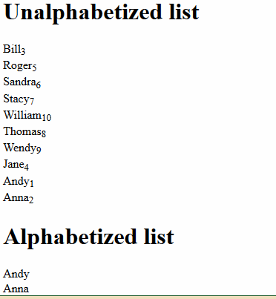

<html>

<body>

<h1>Unalphabetized list</h1>

Bill<sub>3</sub>

<br />

Roger<sub>5</sub>

<br />

Sandra<sub>6</sub>

<br />

Stacy<sub>7</sub>

<br />

William<sub>10</sub>

<br />

Thomas<sub>8</sub>

<br />

Wendy<sub>9</sub>

<br />

Jane<sub>4</sub>

<br />

Andy<sub>1</sub>

<br />

Anna<sub>2</sub>

<h1>Alphabetized list</h1>

Andy

<br />

Anna

<br />

Bill

<br />

Jane

<br />

Roger

<br />

Sandra

<br />

Stacy

<br />

Thomas

<br />

Wendy

<br />

William

</body>

</html>

7. Print the squares of the numbers 1 - 20. Each number should be on a separate line, next to it the number 2 superscripted, an equal sign and the result

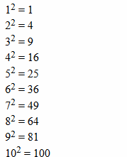

<html>

<body>

1<sup>2</sup>=1

<br />

2<sup>2</sup>=4

<br />

3<sup>2</sup>=9

<br />

4<sup>2</sup>=16

<br />

5<sup>2</sup>=25

<br />

6<sup>2</sup>=36

<br />

7<sup>2</sup>=49

<br />

8<sup>2</sup>=64

<br />

9<sup>2</sup>=81

<br />

10<sup>2</sup>=100

<br />

11<sup>2</sup>=121

<br />

12<sup>2</sup>=144

<br />

13<sup>2</sup>=169

<br /

>

14<sup>2</sup>=196

<br />

15<sup>2</sup>=225

<br />

16<sup>2</sup>=256

<br />

17<sup>2</sup>=289

<br />

18<sup>2</sup>=324

<br />

19<sup>2</sup>=361

<br />

20<sup>2</sup>=400

</body>

</html>

8. Print a definition list with 5 items.

<html>

<body>

<dl>

<dt>HTML</dt>

<dd>A markup language</dd>

<dt>Pen</dt>

<dd>A writing tool</dd>

<dt>Lettuce</dt>

<dd>A vegetable</dd>

<dt>Technology</dt>

<dd>The development of tools which serve as a means to certain objectives</dd>

<dt>Megabyte</dt>

<dd>A unit of data consisting of 1024 kilobytes</dd>

</dl>

</body>

</html>

9. Display an image that has a border of size 2, a width of 200, and a height of 200.

<html>

<body>

<imgsrc="C:\Users\Navya\Desktop/images/DSC03821.JPG” width="200" height="200" alt="DSC03821" border="2" />

</body>

</html>

10. Print ten acronyms and abbreviations of your choosing, each separated by two lines. Specify the data that the abbreviations and acronyms represent

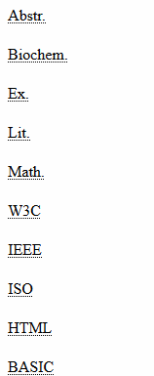

<html>

<body>

<abbr title="Abstract">Abstr.</abbr>

<br /><br />

<abbr title="Biochemistry">Biochem.</abbr>

<br /><br />

<abbr title="Example">Ex.</abbr>

<br /><br />

<abbr title="Literature">Lit.</abbr>

<br /><br />

<abbr title="Mathematics">Math.</abbr>

<br /><br />

<acronym title="world wide web consortium">W3C</acronym>

<br /><br />

<acronym title="Institute of Electrical and electronic engineers">IEEE</acronym>

<br /><br />

<acronym title="International standards organization">ISO</acronym>

<br /><br />

<acronym title="Hyper textmarkup language">HTML</acronym>

<br /><br />

<acronym title="Beginners all purpose symbolic instruction code">BASIC</acronym>

<p>

Move your mouse over an abbreviation or acronym to get more data</p>

</body>

</html>

11. Print two addresses in the same format used on the front of envelopes (senders address in top left corner, receivers address in the center

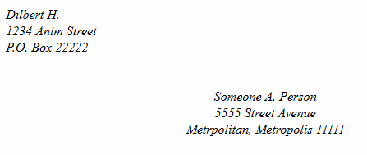

<html>

<body>

<address>

Dilbert H.<br />

1234 Anim Street<br />

P.O. Box 22222

</address>

<br /><br />

<center>

<address>

Someone A. Person<br />

5555 Street Avenue<br />

Metropolitan, Metropolis 11111

</address>

</center>

</body>

</html>

12. Create an HTML page with the following contents:

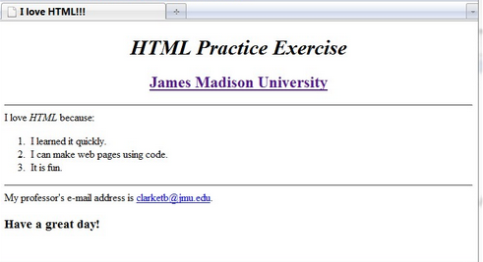

<html>

<title>

I Love HTML!!!

</title>

<body>

<h1 align="center">

<b>

<i>

HTML Practice Exercise

</i>

</b>

</h1>

<h2 align="center">

<b>

<ahref> James Madison University</a>

</b>

</h2>

<hr size="2">

I Love <i>HTML</i> because:

<br>

<br>

<ol type="1">

<li> I learned it quickly.</li>

<li> I can make web pages using code.</li>

<li> It is fun.</li>

</ol>

<hr>

My professor's e-mail address is <a href>clarketb@jmu.edu.</a>

<br>

<h3><b>Have a great day!</b></h3>

</html>

13. Create the following table

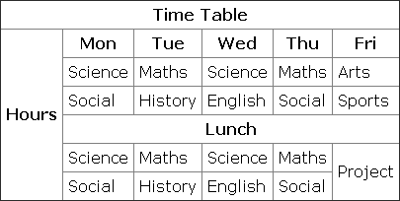

<html>

<body>

<table border="2">

<tr>

<thcolspan="6" align="center">Time Table</th>

</tr>

<tr>

<throwspan="6" align="center">Hours</th>

<th>Mon</th>

<th>Tue</th>

<th>Wed</th>

<th>tdu</th>

<th>Fri</th>

</tr>

<tr>

<td>Science</td>

<td>Maths</td>

<td>Science</td>

<td>Maths</td>

<td>Arts</td>

</tr>

<tr>

<td>Social</td>

<td>History</td>

<td>English</td>

<td>Social</td>

<td>Sports</td>

</tr>

<tr>

<td colspan="5" align="center">Lunch</td>

</tr>

<tr>

<td>Science</td>

<td>Maths</td>

<td>Science</td>

<td>Maths</td>

<td rowspan="2">Project</td>

</tr>

<tr>

<td>Social</td>

<td>History</td>

<td>English</td>

<td>Social</td>

</tr>

</body>

</html>

14. Create a HTML Page which looks like the one given below

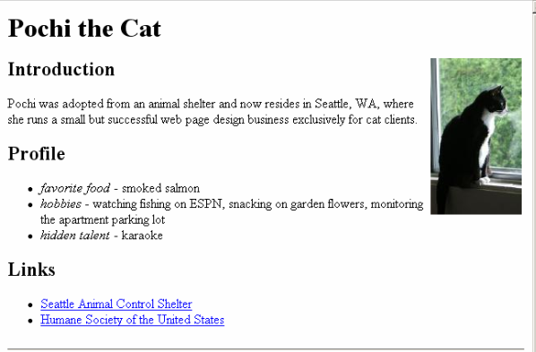

<html>

<body>

<h1>Pochi the Cat</h1>

<imgsrc="C:\Users\Navya\Desktop/images/5544.jpg" width="175" height="250" style="float:right;width=200px;height=100px;"

<h3>Introduction</h3>

<p align="left">

Pochi was adopted from an animal shelter and now residers in seattle, WA, where

she runs a small but successful web page design bussiness exclusively for cat clients.

</p>

<h3>Profile</h3>

<ul type="disc">

<li><i>favorite food</i> - smoked salmon</li>

<li><i>hobbies</i> - watching fishing on ESPN,snacking on garden flowers,monitoring the apartment parking lot</li>

<li><i>hidden talent</i> - karoke</li>

</ul>

<h3>

Links

</h3>

<ul type="disc">

<li><a href>Seattle Animal Control Shelter</a></li>

<li><a href>Humane Society of the United States</a></li>

<br>

<hr>

</body>

</html>